**Fractional double term pole**

Fractional zero transfer function is given by $T(s$) = $\frac{1}{s^{α+β}+a_{1}s^{α}+a_{2}}…$……(17)

Put s = jω, in equation (17) results into $T(jω$) = $\frac{1}{{jω}^{α+β}+a_{1}{jω}^{α}+a_{2}}$…….(18)

Magnitude in dB is given by )| dB =

- 20log $\sqrt{ω^{2\left(α+β\right)}+a_{1}^{2}ω^{α}+a_{2}^{2}+2a_{1}ω^{2α+β}\cos{\frac{πβ}{2}+2a_{2}}ω^{α+β}\cos{\frac{π(α+β)}{2}+2a_{1}a_{2}ω^{α}\cos{(\frac{πα}{2}}) }}$**Calculation procedure**

$({jω)}^{α+β}$

**= $j^{α+β}ω^{α+β}$**

= $({0+1j)}^{α+β}ω^{α+β}$ = ${\text{(cos}\frac{π}{2}+j\text{sin }\frac{π}{2}\text{)} }^{α+β}ω^{α+β}$

Applying De Moivre’s theorem in above equation we get

$=\text{(cos}\frac{(α+β)π}{2}+j\text{sin }\frac{(α+β)π}{2}\text{)}$. $ω^{α+β}$…… (19)

Again,

$({jω)}^{α}$

= ${\text{(cos}\frac{π}{2}+j\text{sin }\frac{π}{2}\text{)} }^{α}$. $ω^{α}$…… (20)

Put equation (19) and (20) in (18) we get

$T(jω$) = $\frac{1}{ {(ω}^{α+β} cos\frac{(α+β)π}{2} + a_{1}ω^{α} cos\frac{απ}{2} + a_{2}) + (jω^{α+β}sin\frac{(α+β)π}{2} + ja_{1}ω^{α}sin\frac{απ}{2} )}$

Magnitude , |) | =

=

=

Now, magnitude in dB, |) | dB

= -20log $\sqrt{ω^{2(α+β)}+a_{1}^{2}ω^{2α}+a_{2}^{2}+\text{2}a_{1}a_{2}ω^{α}\text{ cos}\frac{απ}{2}+2a_{2}ω^{α+β}\text{ cos}\frac{(α+β)π}{2}\text{ +}2a_{1}ω^{2α+β}\text{cos}\frac{βπ}{2}}$

In the sum $ω^{2(α+β)}+a_{1}^{2}ω^{2α}+a_{2}^{2}+\text{2}a_{1}a_{2}ω^{α}\text{ cos}\frac{απ}{2}+2a_{2}ω^{α+β}\text{ cos}\frac{(α+β)π}{2}\text{ +}2a_{1}ω^{2α+β}\text{cos}\frac{βπ}{2}$, $a_{2}^{2}$ dominates at lower frequencies whereas $ω^{2(α+β)}$ dominates at higher frequencies. For approximation we consider $a_{2}^{2}$ = $ω^{2(α+β)} |_{ω=ω_{cr}}$. Now, we obtain corner frequency, $ω_{cr}$ = ${|a_{2}|}^{\frac{1}{α+β}}$.

Following approximation of magnitude is obtained:

1. For ω ≤ , |)| dB = -20log||.
2. For ω >, |)| dB = -20(α+β) log ω.

**Result:** Taking α = 0.9, β = 0.9, $a_{1}=2$, $a_{2}=$ 3 and $ω_{cr}=$ 1.842.

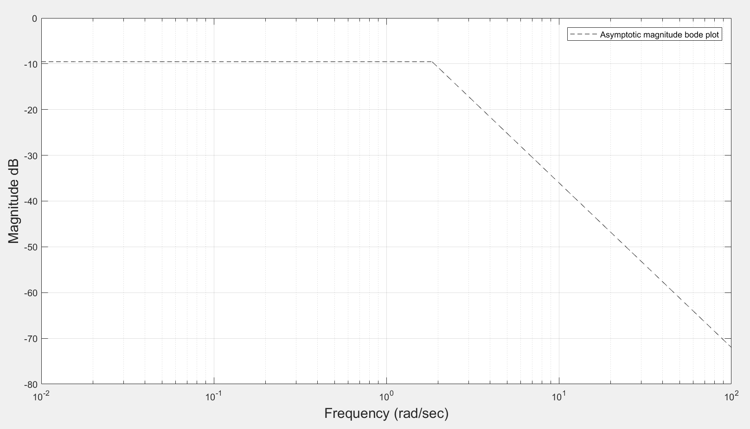

**Figure 3.13-Asymptotic magnitude bode plot of fractional double term pole.**

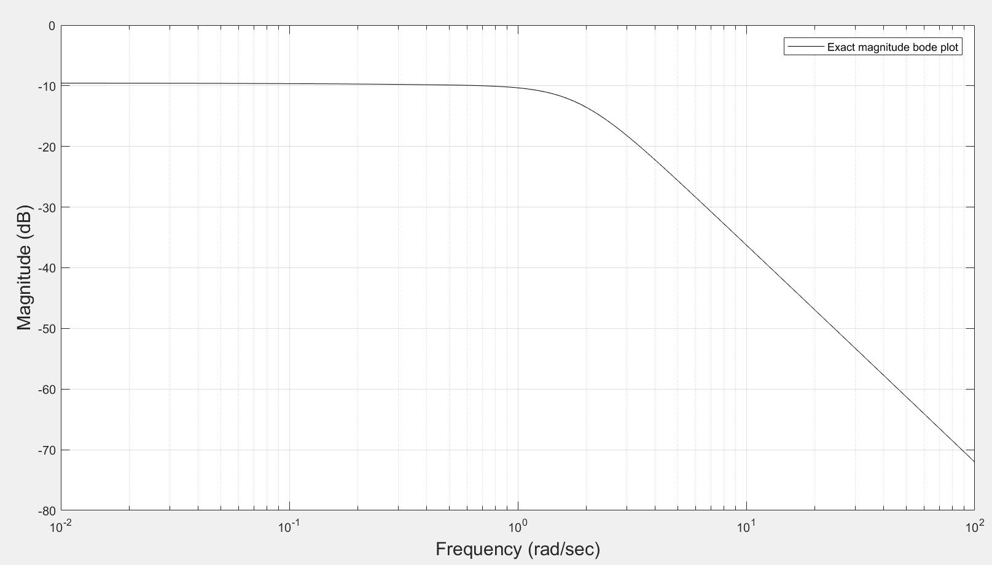

**Figure 3.14-Exact magnitude bode plot for fractional double term pole.**

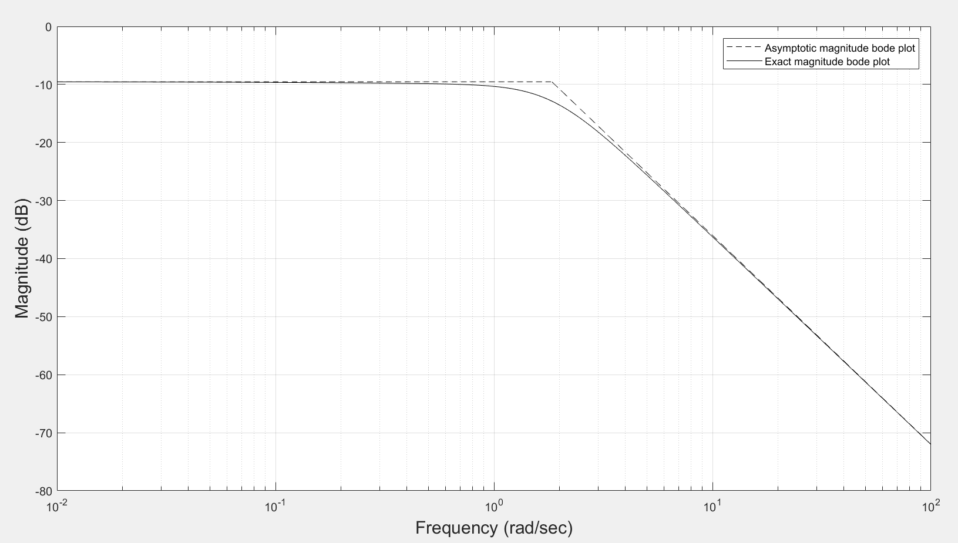

**Figure 3.15-Exact and asymptotic magnitude bode plot for fractional double term pole.**